CURRICULUM VITAE
Dr. Ashraf Mohammed Elyamany Metwally Aly
M.B., B.Ch, M.Sc. Doctorate Degree. American Fellowship training program

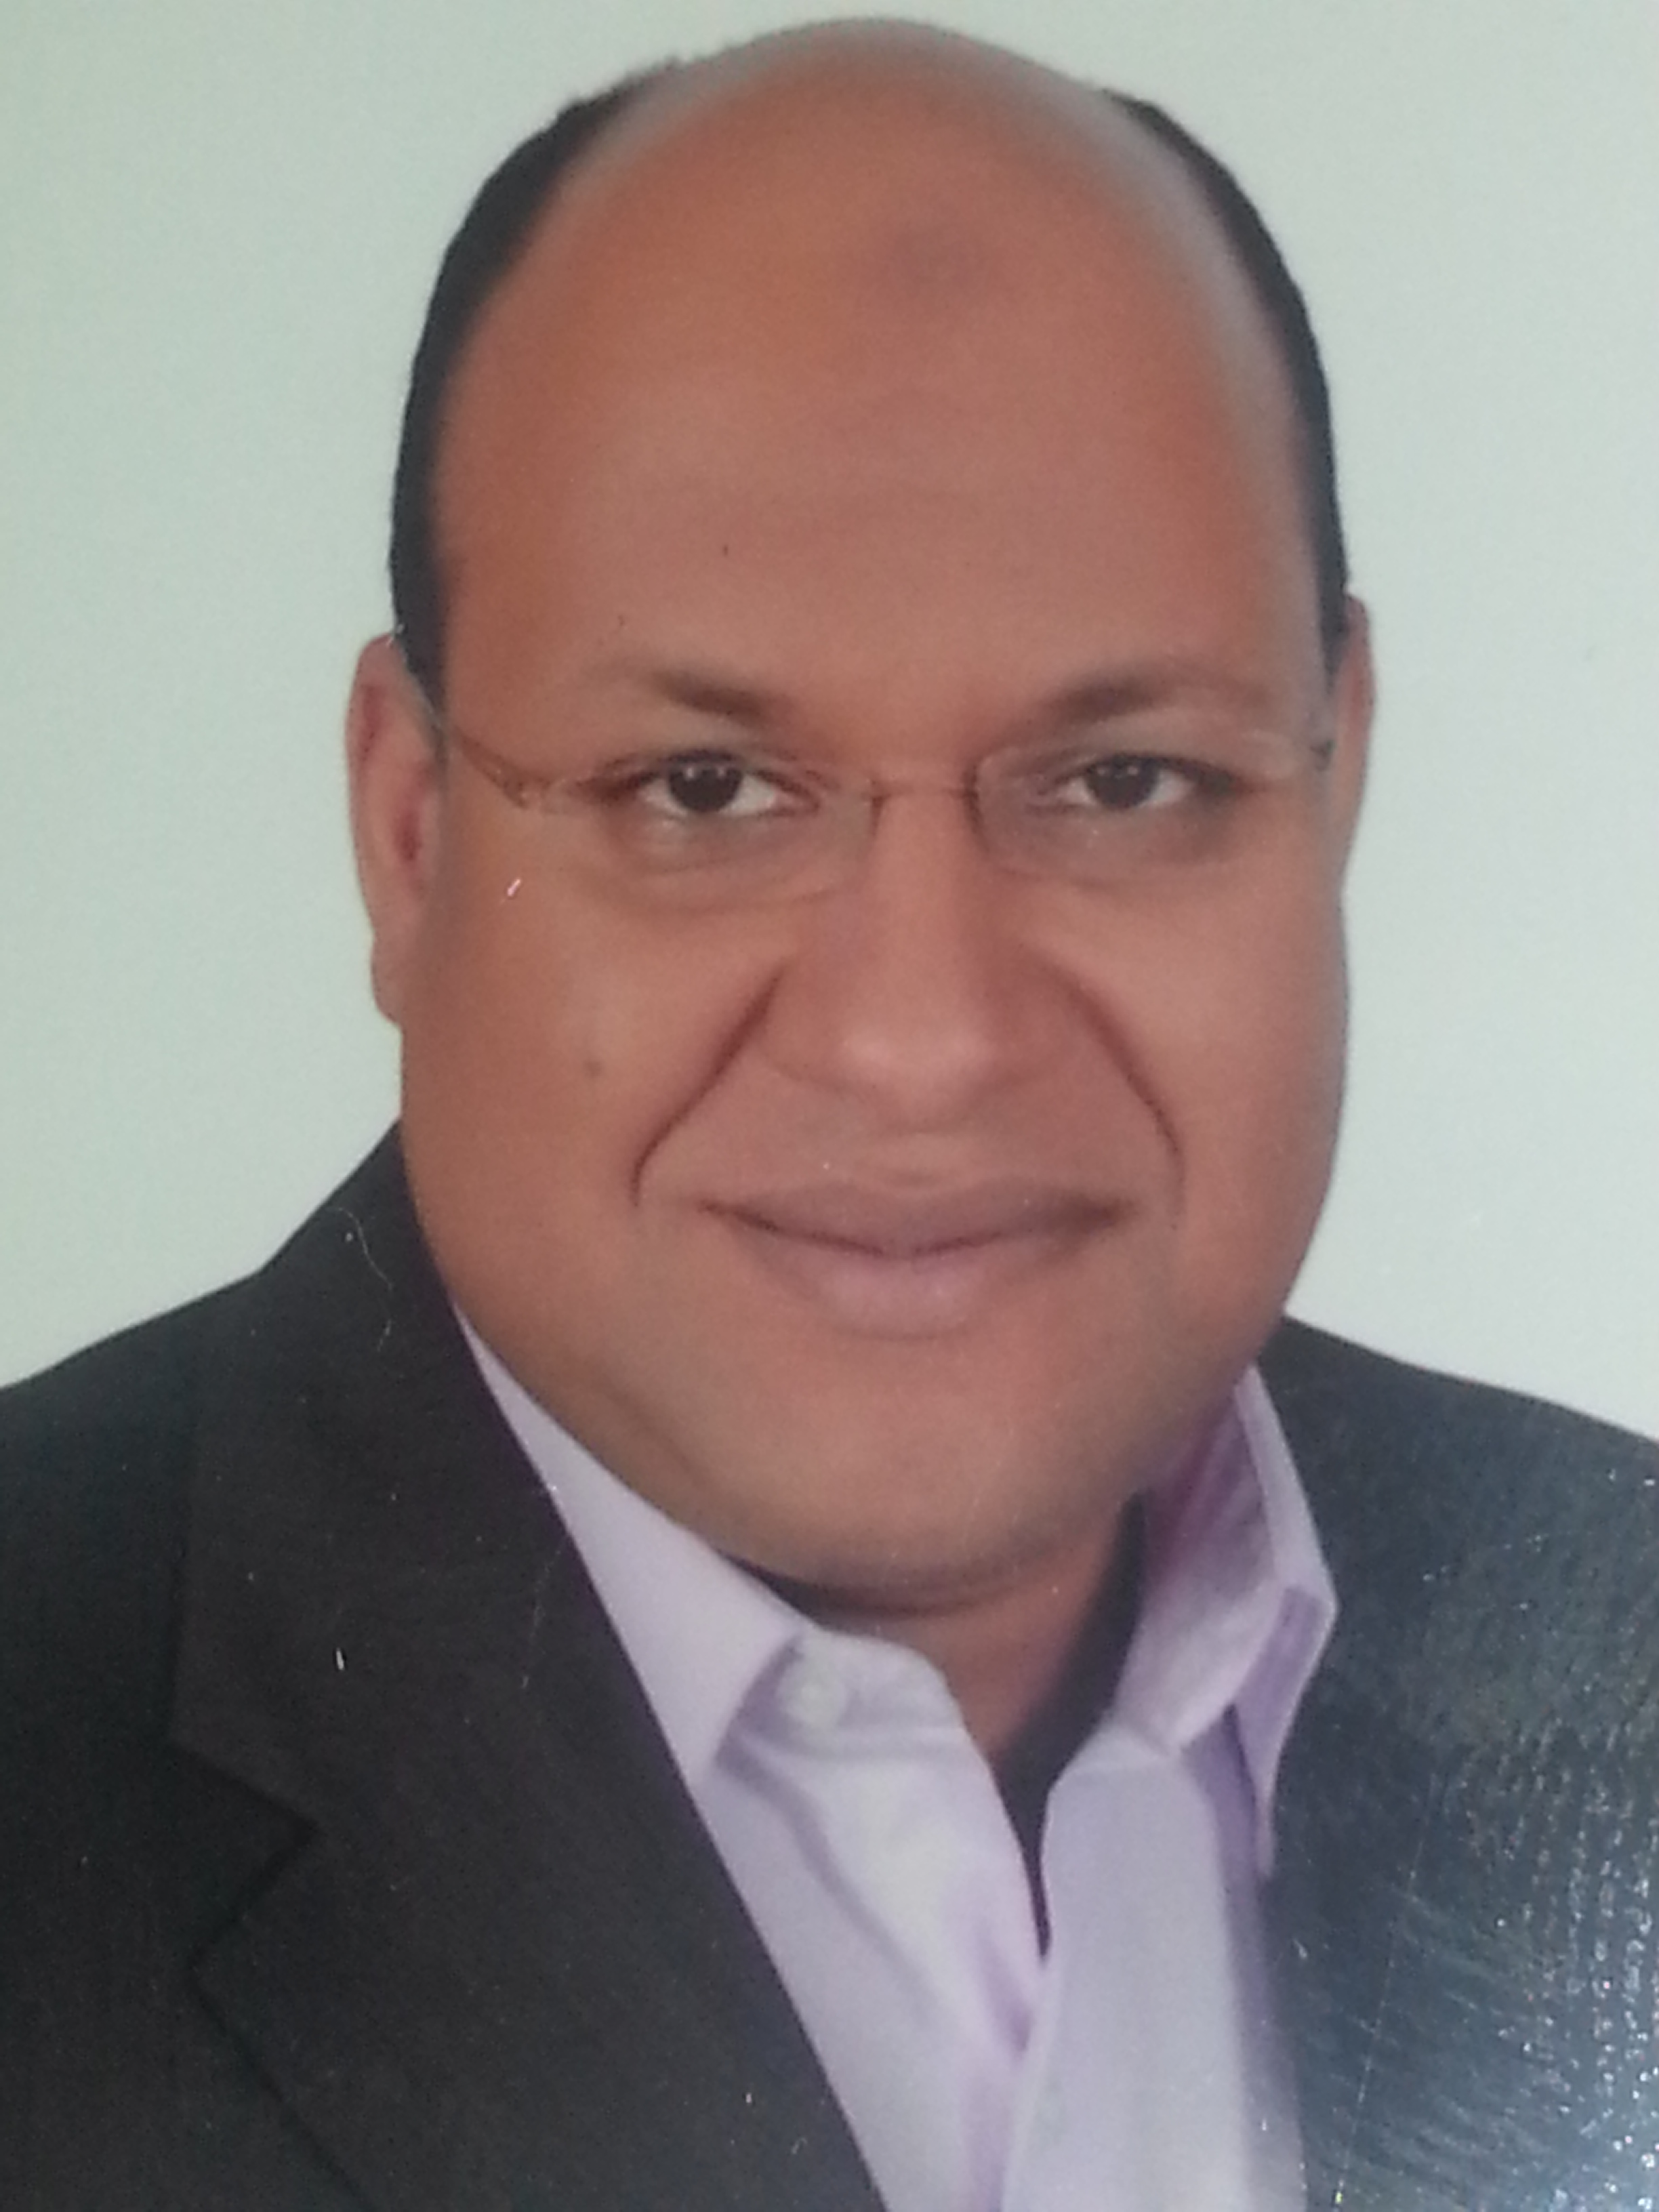

Personal Data:

Surname : Aly

First Names : Ashraf Mohammed Elyamany Metwally

Address: medical oncology department south Egypt cancer institute, Assiut Egypt

Telephone No. : +966 0501013743 (KSA)

E-mail : elyamany23@gmail.com

Date and place of Birth : 23/1/1973 Alexandria, Egypt

Marital status: Married to Dr, Enaas Hassan Abodaif, dermatology resident ,with 3 kids.

Current job:
-Lecturer of medical oncology south Egypt cancer institute Assiut University, Egypt.
- Consultant Medical oncology at, King Saoud Medical City (KSMC).A Riyadh. KSA

Jobs :
-Consultant of medical oncology and haematology, Alkharga hospital, New Valley governorate, ministry of health, Egypt
-Consultant of medical oncology, New Valley governorate health insurance, Egypt.
- Medical oncologist at king Fahd Medical City Riyadh KSA.
- Consultant medical oncology at Prince Faisal Cancer Centre Alquasem KSA

job description:

- Participate in patient care, in the inpatients service and outpatients clinic.
- Provides orientation, teaching and assistance in evaluation of the medical students, residents, and assistant lecturers.
- Participate in departmental research activities.
- Participate in different scientific activities in the department e.g. journal club , ground rounds, tumour Board….etc
- Participate in supervision of master and doctorate degree thesis for medical oncology resident and assistant lecturers.

Community participation:

Participated in establishment of oncology treatment unit at Alkharga hospital, New Valley governorate, ministry of health, Egypt

Education and qualifications:
1-Bachelor of Medicine and Surgery 1998, Assiut University, Egypt.
2-Master degree in internal medicine (M.Sc.) 2002, Assiut University, Egypt.
3-Doctorate degree (PHD) in medical oncology 2011, Assiut University,Egypt.
4- clinical Fellowship training program at wake forest university NC, USA 2006-2008
Western experience : Clinical fellowship training program wake forest university NC.USA

Professional Experiences:

From 3/1999 To 5/2002:- Resident in medical oncology department, South Egypt cancer institute Assuit University, Egypt

From 5/2002To 2/2003:-. Demonstrator at medical oncology department, South Egypt cancer institute Assuit University, Egypt

From 2/2003To 2/2011:- Assistant lecturer medical oncology department, South Egypt cancer institute Assuit University, Egypt
From 5/2012 : Senior registrar medical oncology department king fahd medical city al Riyadh KSA.
From 3/2011 : Lecturer in medical oncology department, South Egypt cancer institute Assuit University, Egypt

From 9/2006 To 9/2008 : Full 2 years hematology oncology Fellowship clinical training program at wake forest university NC, USA
It included outpatient clinics, in patient bed side rounds, tumor boards, all the scientific activities with CME credit, clinical research and International conferences.
Attended activities of institute of regenerative medicine (WFIRM) wake Forest University

Additional training;
6 months training in performing diagnostic upper and lower endoscopy for at Assuit university hospital endoscopy unit.

Membership Active ESMO member.

Researches:

Master Degree thesis
Incidence and risk factors of deep venous thrombosis in admitted cancer patient in south Egypt cancer institute.

Doctorate Degree thesis

Role of neoadjuvant chemotherapy in locally advanced bladder cancer

SUPERVISION:
MASTER DEGREE THEIS
AML in South Egypt Cancer Institute prevalence and treatment results, 2014.

Authorship:
One of the authors of the following book:
Management of Cancer Bladder (Klinische Fächer LAP LAMBERT Academic Publishing (26.03.2013) ISBN-13:978-3-659-35469-4)
Links to the book:
https://www.morebooks.de/store/de/book/management-of-cancer bladder/isbn/978-3-659-35469-4
https://www.morebooks.de/assets/product_images/9783659354/big/9161770/management-of-cancer-bladder.jpg?locale=de

Awards:
Second Place Award Of Lung Cancer Academy:
Small Cell Lung Cancer (SCLC) In Never Smokers And Response To Oral Tyrosine Kinase Inhibitor(TKI): Case Report, 3rd Annual Scientific Conference Of Saudi Lung Cancer Association, Thoracic Oncology Forum TOF2015.

Publications:

- A Phase II Study of Neo-Adjuvant Vinorelbine/Cisplatinum Chemotherapy Combination in Locally Advanced Bladder Cancer. A Abd El-Wraith, A Abd El-Aziz, A Zidan, A El-Yamany: ICACT,2007 Abstract 196.

- The optimal sequence of radiotherapy and chemotherapy in adjuvant treatment of breast cancer. Hamza Abbas, Ashraf Elyamany, Mohamed Salem, Ahmed Salem, Salah Binziad and Basem Gamal: International Archives of Medicine 2011, 4:35.

- Organ Preservation in Bilharzial Bladder Cancer in Egypt: Single Institutional Experience. Hamza Abbas, Mohamed Abdel Aboziada, Mostafa Elsayed Abdalwanis, Mohamed Abdallah El-Gmal, Ahmed Mokhtar, Mohamed Ahmed Abo-Almagd, Farouk Morad Amr, Ashraf Elyamany. Journal of Cancer Therapy, 2012, 3, 57-63

- Self-Expandable Metal Stents in Palliation of Inoperable Esophageal& Gastro-Oesophageal Carcinoma. Ahmed A. S. Salem, Ashraf Elyamany, Esam Abd-el Mohsen & Amen H. Zaky. Cancer and Clinical Oncology Vol. 1, No. 1; 2012.

- Comparison of Gabapentin, Prochlorperazine and Ondansetron for Prevention of Delayed Chemotherapy-Induced Nausea and Vomiting. Khaled M. Fares; Sahar A.Mohamed; Nashwa Abd elraouf and Ashraf Elyamany Med. J. Cairo Univ, Vol. 80, No. 2, June: 273-279, 2012.

- Management of bladder cancer: A literature review. Ashraf Elyamany, Mohamed Aboziada and Hamza Abbas. International Research Journal of Medicine and Medical Sciences Vol. 1(2), pp. 13-26, February 2013.Review.

- Upper Egypt experience in bladder preservation using concurrent chemoradiotherapy. Ahmed M Maklad, Elsayed M Ali, Ashraf Elyamany and Emad Eldin Nabil International Archives of Medicine May 2013, 6:21

- The impact of radiotherapy and concomitant weekly cisplatin on treatment outcome of locally advanced nasopharyngeal carcinoma. Ali Mohammed Ali , Ashraf M Elyamany , Kasr-Al-Aini Journal of Clinical Oncology and Nuclear Medicine 2013.

- “Oncoplastic Breast Surgery Using Latissimus Dorsi Miniflap South Egypt Cancer Institute Experience”: Hesham Hamza, MD; Hussain Fakhry, MD; Kassim Abdelazeem, MD; Mahmoud M. Mostafa, MD; Gamal Amira, MD; Samir E. Shehata, MD; Ashraf Elyamany, MD ,South Egypt Cancer Institute, EGYPT . 36th Annual Symposium of the American Society of Breast Disease, poster NO: 40 ,2012 https://www.asbd.org/education/abstracts/2012SymposiumAbstracts.pdf‎
http://repository.um.edu.my/31592/1/2012SymposiumAbstracts.pdf

- Gemcitabine versus cisplatin concomitant with radiotherapy for locally advanced squamous cell carcinoma of the head and neck. Elsayed Mostafa Ali, Emad nabil Hassan, Ashraf Elyamany, Ahmed M Maklad, Ahmed Gaber Abdelraheem. J Clin Oncol 32, 2014 (suppl; abstr e17039)

- The outcome of treatment of localized cancer prostate in the Governorate of Souhag. Ali Mohammed Ali and Ashraf M Elyamany , Med. J. Cairo Univ., Vol. 82, No. 2, June: 149-158, 2014 www.medicaljournalofcairouniversity.net

- Comparative study of Gemcitabine versus Cisplatin concurrent with radiotherapy for locally advanced head and neck cancer. Elsayed M Ali, Emad Eldin Nabil , Ashraf Elyamany , Ahmed M. Maklad , Ahmed Gaber Abdelraheem. Journal of Cancer Treatment and Research 2014; 2(4): 37-44.
- Small Cell Lung Cancer ( SCLC) in Never Smokers And Response To Oral Tyrosine Kinase Inhibitors (TKI): Case Report Ashraf M. Elyamany , Abdullah K. AlTwairgi Medical Oncology Department ,Comprehensive Cancer Center, King Fahad Medical City, Riyadh, Saudi Arabia, 3rd Annual Scientific Conference Of Saudi Lung Cancer Association, Thoracic Oncology Forum TOF2015 KSA.

- OUTCOME OF PATIENT GLIOBLASTOMA (GBM) :SINGLE CANCER CENTER EXPERIENCE., Abdullah K. AlTwairgi,Waleed AlGhreeb, Ashraf M. Elyamany Medical Oncology Department ,Comprehensive Cancer Center, King Fahad Medical City, Riyadh, Saudi Arabia, abstract ,kfmc research day December 2014, KSA

- Outcome of patients with glioblastoma in Saudi Arabia: Single center experience. Abdullah Khalaf Altwairgi, Waleed Ali Alghareeb, Gaaem Mohammed Yahya, Wafa AlShakweer, Ashraf Elyamany. 2015 ASCO Annual Meeting J Clin Oncol 33, 2015 (suppl; abstr e13047)

- “Patterns of Failure and Survival in Patients with Nasopharyngeal carcinoma treated with Intensity Modulated Radiation Therapy in Saudi Arabia”Ahmad Marzouk Maklad, ,Yasser Bayoumi,,Mohamed Abdalazez Senosy Hassan, AbuSaleh A. Elawadi, Hussain AlHussain, Ashraf Alyamany, Saleh AlDahri, Khalid Hussain AL-Qahtani, Mobarak AlQahtani, Mutahir A. Tunio, MBBS, Full-text versions of the publish-only abstracts will appear on www.asco.org andjco.ascopubs.org in a fully searchable format beginning January 11, 2016. abstract #157201.

International meetings Attended:
- ASCO meeting Chicago USA ,2007.
- Personalized therapy for breast cancer first annual meeting, Miami ,USA,2008.
- ASCO meeting Chicago USA, 2008
- 4- ASCO palliative care meeting Cairo Egypt ,2009.
- Panarab meeting Cairo Egypt ,2009.
- The 4th scientific Conference of the South Egypt Cancer Institute, Assiut University, February 2011
- International Obstetrics and gynecology meeting Cairo Egypt , 2011.
- European society for medical oncology,37th ESMO congress 2012.
- KRAS resting workshop –update the experience in kingdom of Saudi of Saudi Arabia ,guidelines for the quality program 2012.
- European Society for Medical Oncology (ESMO) Summit Saudi Arabia 2013. Translational to Clinical Research major advances 2013 update. 6-7 March 2013. Dammam. KSA.
- 7th middle east best of CTRC_AACR san Antonio breast cancer symposium 2013.
- The Power Of Multidisciplinary Team Approach ,Saudi Society Of Endocrinology And Metabolism 2013.
- Saudi health exhibition and conference, Saudi Ministry Of Health 2014.
- Hematology year review, Saudi society of blood and marrow transplant (KSAU-HS) 2014.
- Basic Life Support Provider. 2015. Riyadh, KSA.
- 3rd Annual Scientific Conference Of Saudi Lung Cancer Association, Thoracic Oncology Forum TOF2015.
- Breast Cancer Preceptorship Program ,King Faisal Specialist Hospital And Research Center Riyadh ,2015.
- Personalized Cancer Treatment –A Multidisciplinary Approach, Emirates Oncology Conference 2015
19-6th European lung cancer meeting –ELCC APRIL 2016

